Fourth meeting for sprint 2 (Team 77)

## Meeting date | time Date | Time | Meeting location Location

## 13/10/18 7pm-8pm 1hr online-discord (link: http://duscird.gg/CeyTQc)

|  |  |  |  |  |  |  |  |
| --- | --- | --- | --- | --- | --- | --- | --- |
| |  |  | | --- | --- | | Meeting called by | Keonwoo Lee | | Note taker | Keonwoo Lee | | Timekeeper | Keonwoo Lee | | Attendees  Keonwoo Lee, Dipper Dai, Yiming Pan, Anqi Cui  Non-Attendees |

Discussion Conversation

The purpose of having the meeting is to check the progress of week 11’s sprint 2 activities done by each team member and to lay another plan for week12’s sprint 2 activities based on the retrospect.

**Week 11’s activities done**

* Story 11: Advertisement
* The customer can now view some advertisements of the company’s rental cars as well as the company’s contact details, Facebook page link and Twitter link from the welcome page.

T**o do list for week12’s sprint 2 activities – focused on Story 27: Car description and story 15: Browser (Most Rented Cars)**

|  |  |  |
| --- | --- | --- |
| Action items | Person responsible | Deadline |
| **Topic 1** Create a prototype for the table displaying the most rented cars in the last one month, a button “browse most rented cars”, a chart and verify the story is complete  (related to task ID T16, T17, T21) | Keonwoo Lee | 16/10/18 |
| **Topic 2** Create a button “View More” next to each car information and its html, and verify the story is complete (related to task ID T10, T15) | Dipper Dai | 16/10/18 |
| **Topic 3** Write code to enable the button “View More” to provide the detailed car information with an image, and to automatically populate the page with car information from the database (related to task ID T12, T13) | Yimming Pan | 16/10/18 |
| **Topic 4** Create a prototype for Car Description page, and write test cases (related to task ID T09, T14 and T12) | Anqi Cui | 16/10/18 |

**Special notes Type additional notes here**

* Task ID T18 and T19 (write codes to enable the button “browse most rented cars” that calculates for the most rented cars in the last one month, and to display the calculated information) seem unnecessary since it is expected that these tasks can be done through building a html (T17)

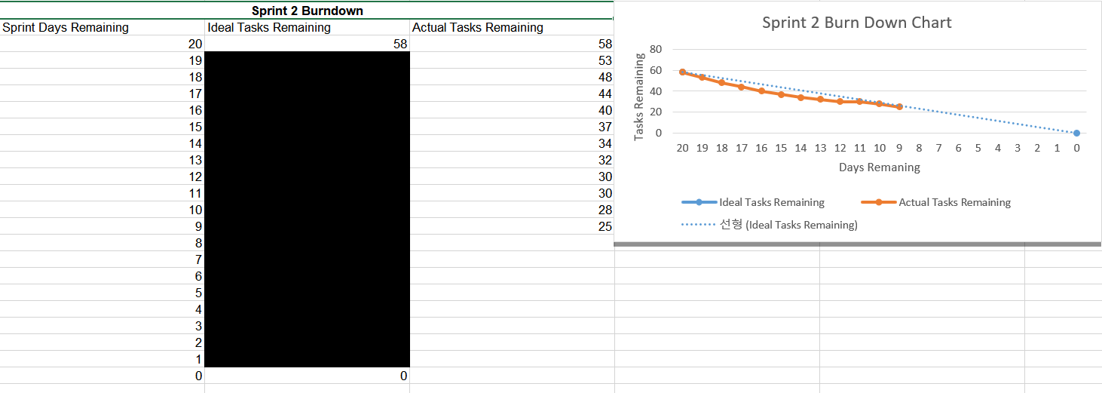**Burndown chart up to date**

**Next meeting:** 16/10/18 Tuesday 4pm-6pm in S-block